**Lab III**

**Developing Web Client application using JsFiddle**

**HTML5 Local Database, Mash-up application, REST Web Services**

*Sailaja Pedaprolu, 16157493*

An application named ‘Ola Traveller!’ has been developed. The features available in this application are: routing the travel between the departing and destination cities using google map service. Now, this service is mashed up along with the twitter service, where the user can tweet and let the world know what he is feeling. Another feature is preparation of a checklist which imbibes Local database storage.

The home screen appears like below:

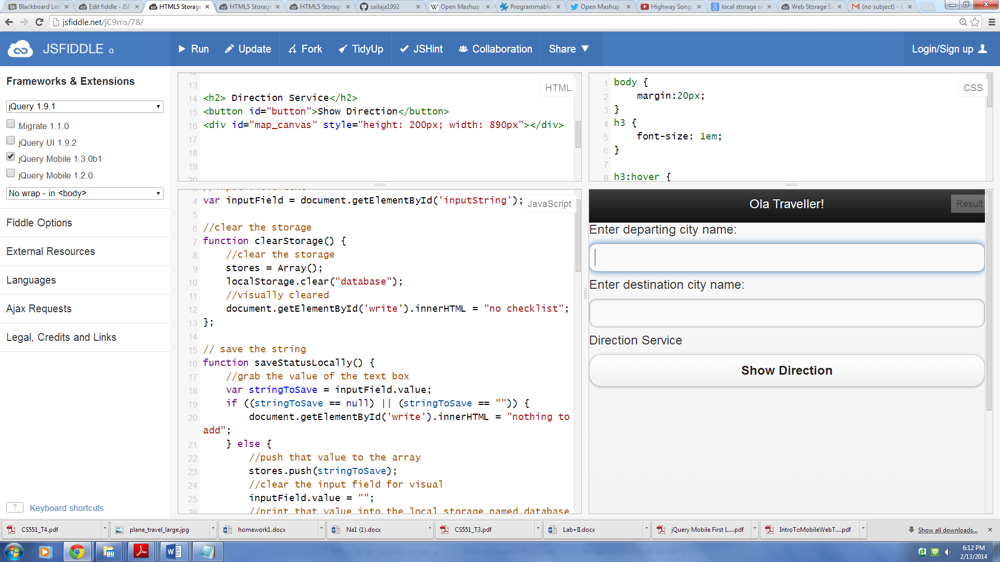

The next screen shows the city names being entered and when the “show direction” button is clicked, the google map routes the source with the destination.

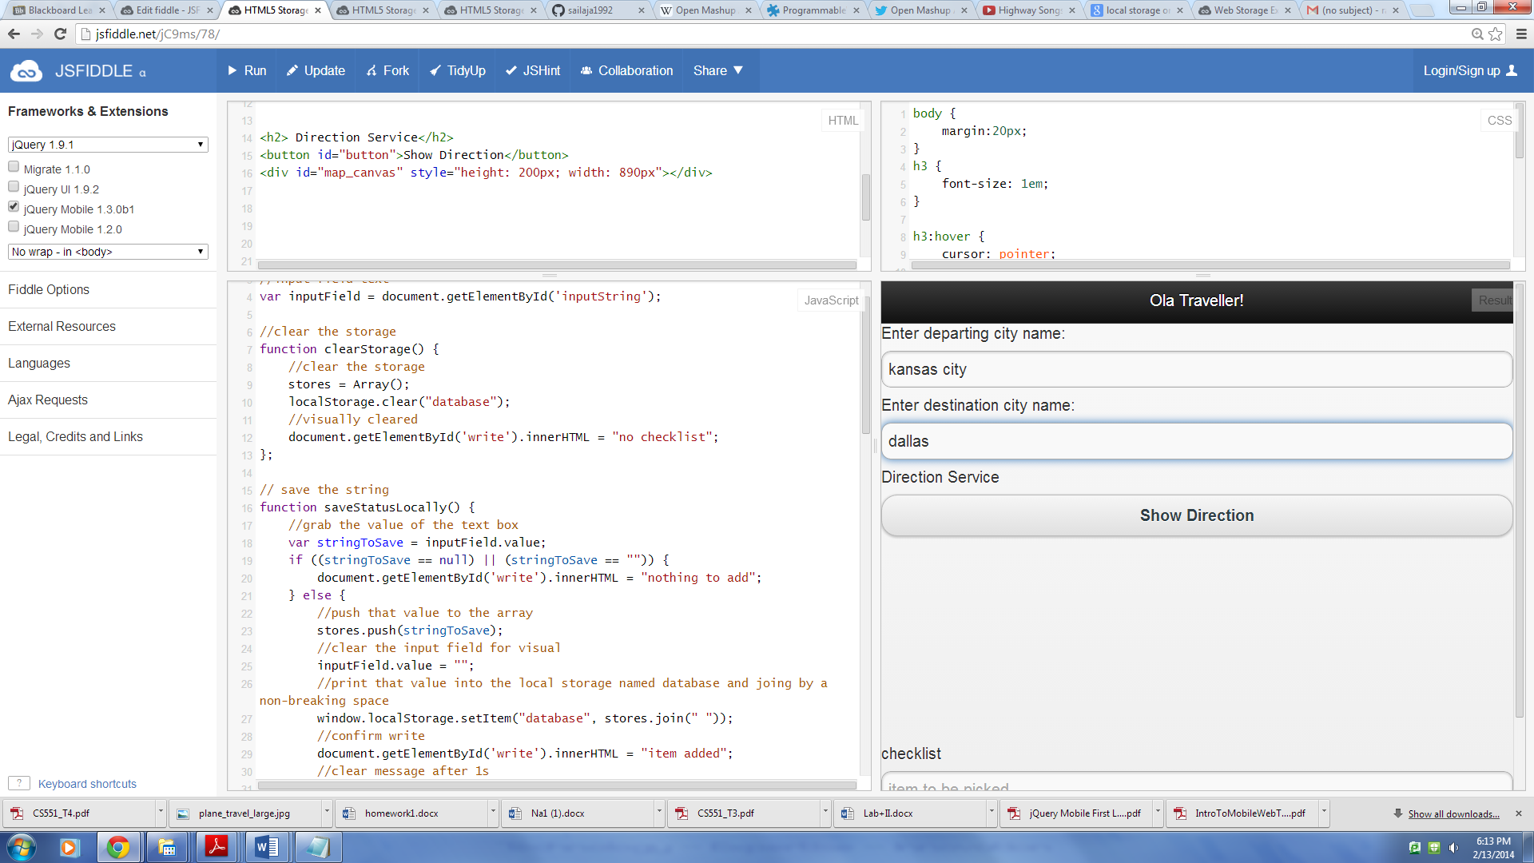

And, the map appears:

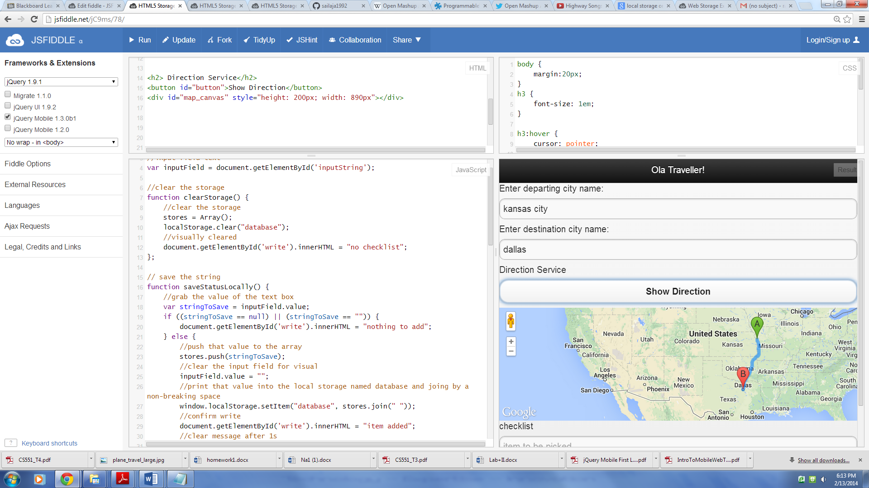

Now, HTML5 Local storage is implemented. The user can create a online checklist.

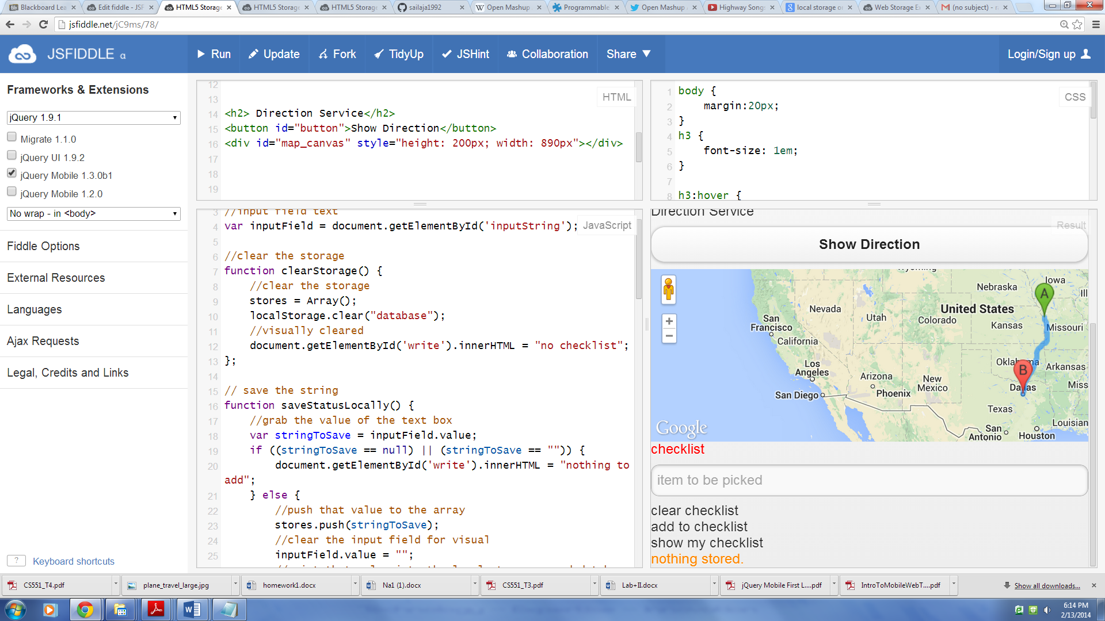

The items to be packed for travel are entered in the “item to be picked” text field, the ‘add to checklist’ is clicked. The items get stored locally.

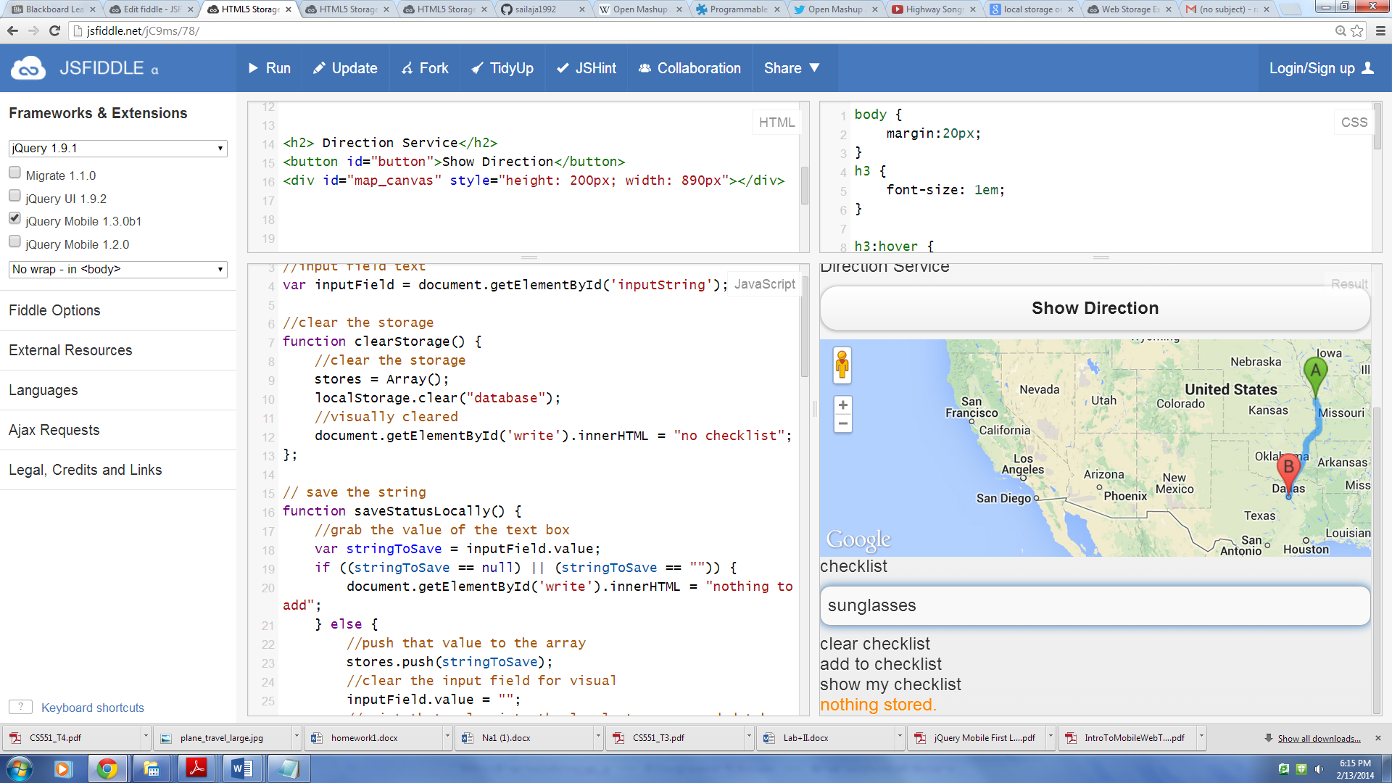

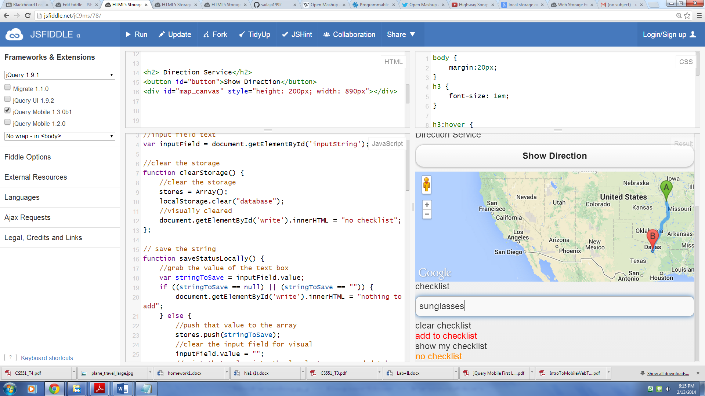

Once, all the items are entered, ‘show my checklist’ can be clicked to view the list of items.

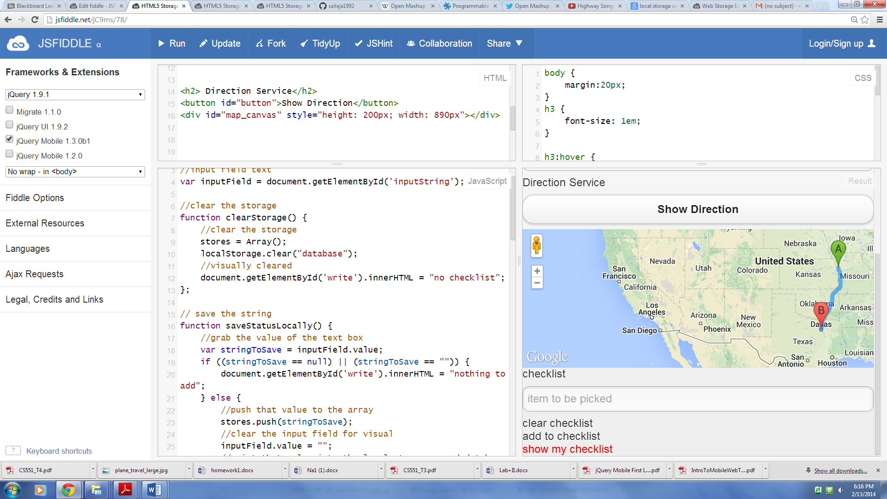

The list of items are displayed below

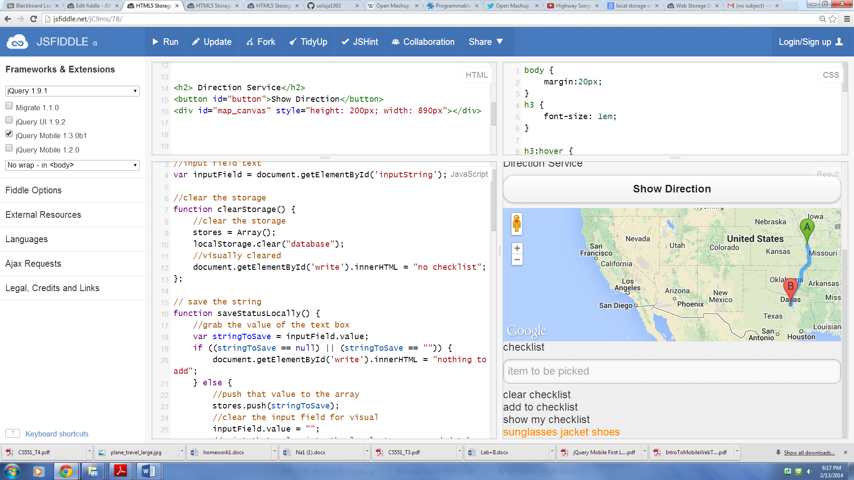

If the user wishes to have a new check list, he can clear the checklist and make a new one

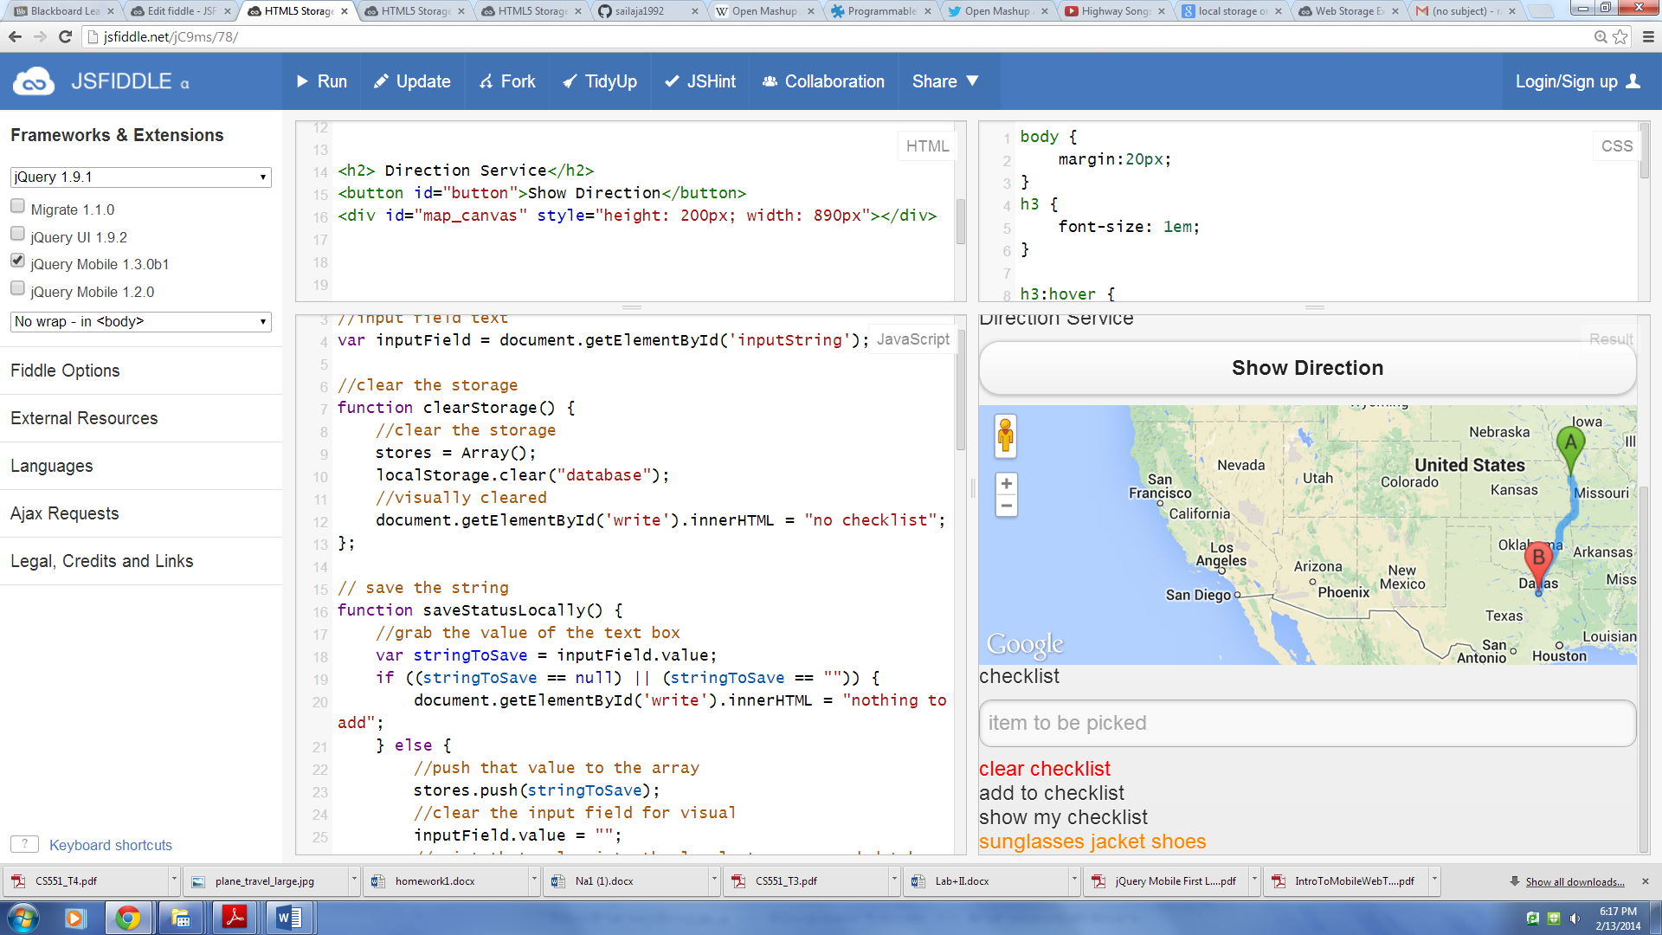

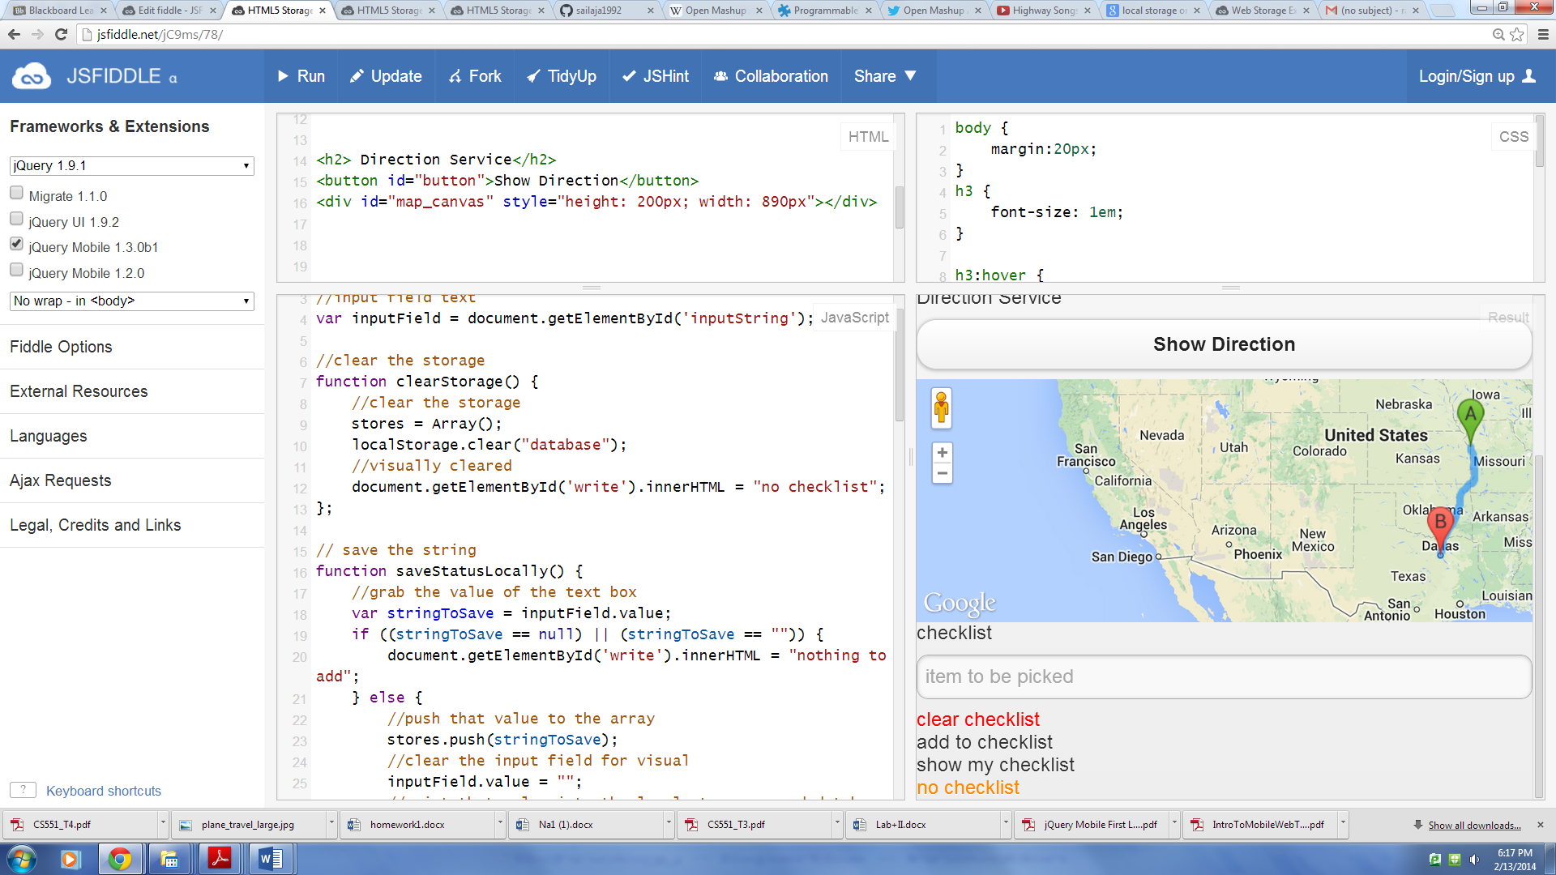

The twitter API is used in the following way. If the user wishes to tweet then he can click on the options given to go the twitter, log in and do what he wishes to.

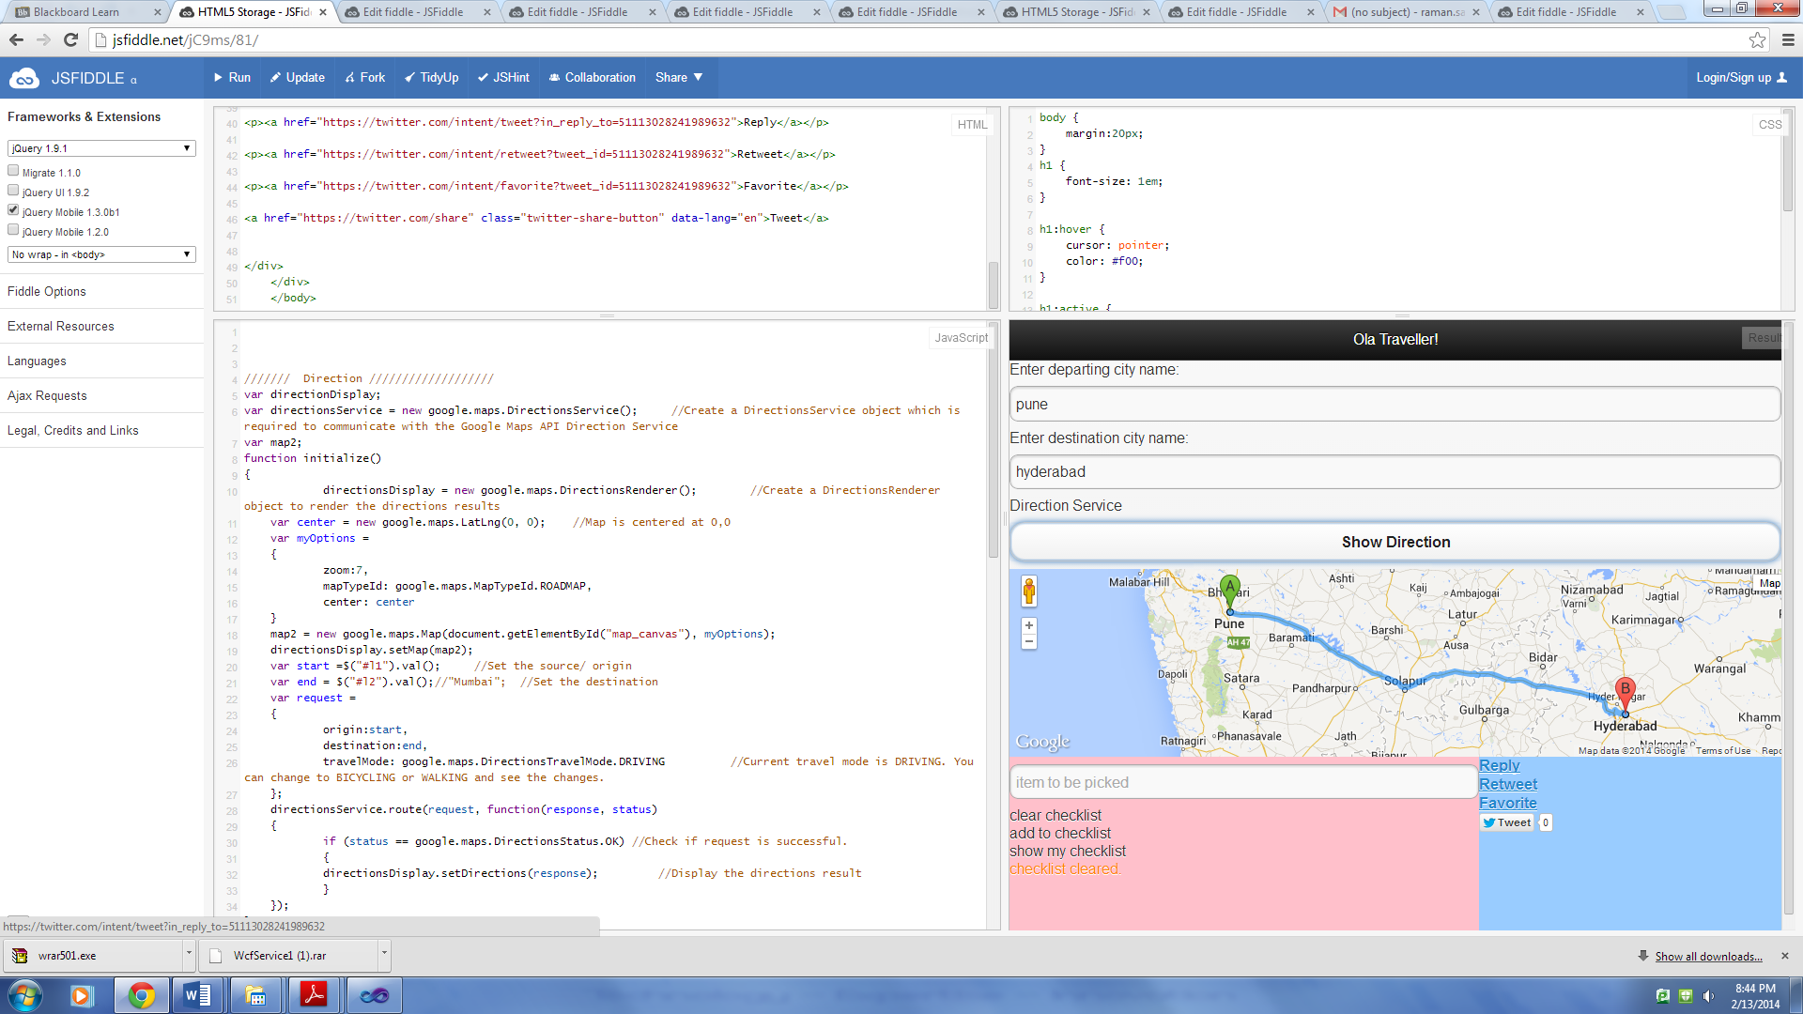

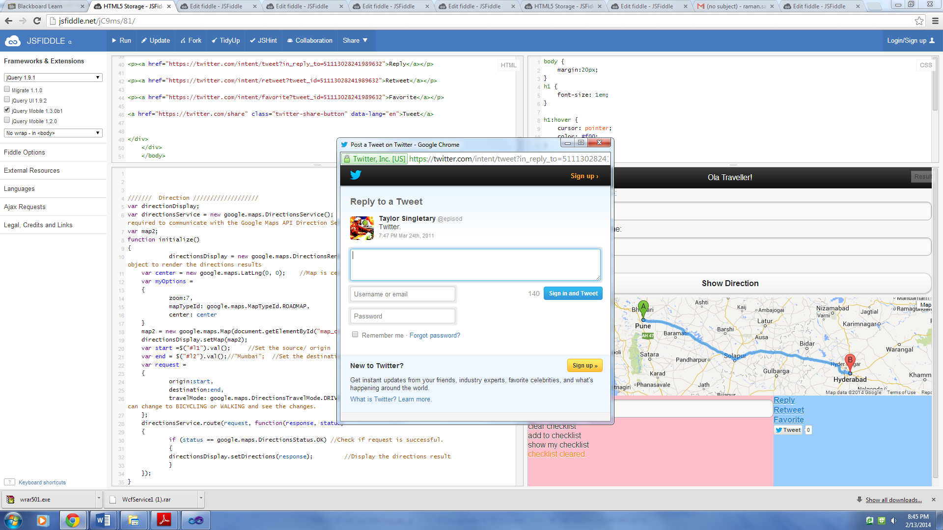

Below are the screenshots of restful web services:

